Apple iPhone 3GS |  |  | Blackberry Torch 9800
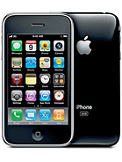 |  |  | 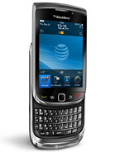
Camera | 2 MP |  | Camera | 5 MP
Storage | 64 GB |  | Storage | 4 GB
Music | Yes |  | Music | Yes
Video | Yes |  | Video | Yes
E-Mail | Yes |  | E-Mail | Yes
Connectivity | WiFi, Bluetooth, GPS |  | Connectivity | WiFi, Bluetooth, GPS
Motorola Defy |  |  | Nokia C3-01
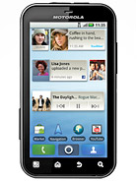 |  |  | 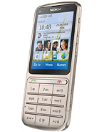
Camera | 5 MP |  | Camera | 5 MP
Storage | 2 GB |  | Storage | 30 MB
Music | Yes |  | Music | Yes
Video | Yes |  | Video | Yes
E-Mail | Yes |  | E-Mail | No
Connectivity | WiFi, Bluetooth, GPS |  | Connectivity | WiFi, Bluetooth

Sony Ericsson Xperia X10 |  |  | LG Cookie GS290
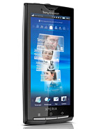 |  |  | 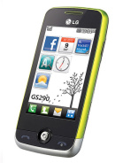
Camera | 8 MP |  | Camera | 2 MP
Storage | 1 GB |  | Storage | 48 MB
Music | Yes |  | Music | Yes
Video | Yes |  | Video | Yes
E-Mail | Yes |  | E-Mail | Yes
Connectivity | WiFi, Bluetooth, GPS |  | Connectivity | Bluetooth
LG Optimus White |  |  | Motorola Atrix
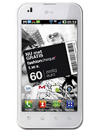 |  |  | 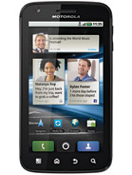
Camera | 5 MP |  | Camera | 5 MP
Storage | 2 GB |  | Storage | 16 GB
Music | Yes |  | Music | Yes
Video | Yes |  | Video | Yes
E-Mail | Yes |  | E-Mail | Yes
Connectivity | WiFi, Bluetooth, GPS |  | Connectivity | WiFi, Bluetooth, GPS

HP Veer |  |  | Sony Ericsson W205
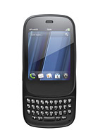 |  |  | 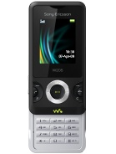
Camera | 5 MP |  | Camera | 1 MP
Storage | 8 GB |  | Storage | 5 MB
Music | Yes |  | Music | Yes
Video | Yes |  | Video | Yes
E-Mail | Yes |  | E-Mail | No
Connectivity | WiFi, Bluetooth, GPS |  | Connectivity | Bluetooth
Samsung Chat 335 |  |  | Nokia N73
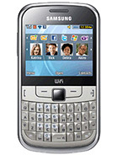 |  |  | 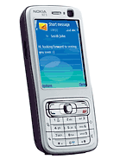
Camera | 2 MP |  | Camera | 3 MP
Storage | 60 MB |  | Storage | 42 MB
Music | Yes |  | Music | Yes
Video | Yes |  | Video | Yes
E-Mail | Yes |  | E-Mail | Yes
Connectivity | WiFi, Bluetooth |  | Connectivity | Bluetooth

Sony Ericsson W8 |  |  | LG GW300
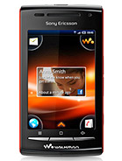 |  |  | 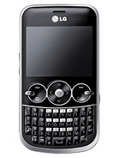
Camera | 5 MP |  | Camera | 2 MP
Storage | 128 MB |  | Storage | 15 MB
Music | Yes |  | Music | Yes
Video | Yes |  | Video | No
E-Mail | Yes |  | E-Mail | No
Connectivity | WiFi, Bluetooth, GPS |  | Connectivity | Bluetooth
HTC Touch |  |  | Nokia 5230
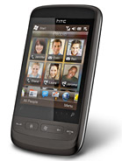 |  |  | 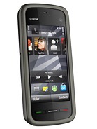
Camera | 3 MP |  | Camera | 2 MP
Storage | 256 MB |  | Storage | 70 MB
Music | Yes |  | Music | Yes
Video | Yes |  | Video | Yes
E-Mail | Yes |  | E-Mail | Yes
Connectivity | WiFi, Bluetooth, GPS |  | Connectivity | Bluetooth, GPS

Sony Ericsson P990i |  |  | Nokia 6500
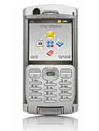 |  |  | 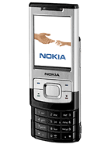
Camera | 2 MP |  | Camera | 3 MP
Storage | 64 MB |  | Storage | 20 MB
Music | Yes |  | Music | Yes
Video | Yes |  | Video | No
E-Mail | Yes |  | E-Mail | Yes
Connectivity | WiFi, Bluetooth |  | Connectivity | Bluetooth
Samsung Mini |  |  | Samsung Galaxy S2
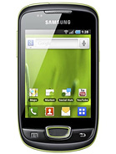 |  |  | 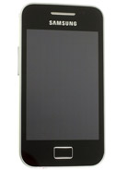
Camera | 3 MP |  | Camera | 2 MP
Storage | 160 MB |  | Storage | 32 GB
Music | Yes |  | Music | Yes
Video | Yes |  | Video | Yes
E-Mail | Yes |  | E-Mail | Yes
Connectivity | WiFi, Bluetooth, GPS |  | Connectivity | WiFi, Bluetooth, GPS

Nokia 2220 Slide |  |  | Nokia 5233
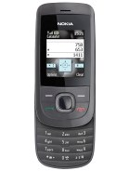 |  |  | 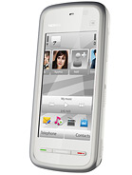
Camera | 0.5 MP |  | Camera | 2 MP
Storage | 32 MB |  | Storage | 70 MB
Music | No |  | Music | Yes
Video | No |  | Video | No
E-Mail | Yes |  | E-Mail | Yes
Connectivity | N/A |  | Connectivity | Bluetooth
Sony Ericsson W880i |  |  | Nokia E63
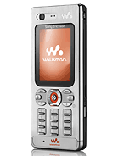 |  |  | 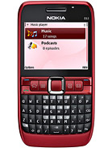
Camera | 2 MP |  | Camera | 2 MP
Storage | 16 MB |  | Storage | 120 MB
Music | Yes |  | Music | Yes
Video | Yes |  | Video | No
E-Mail | Yes |  | E-Mail | Yes
Connectivity | Bluetooth |  | Connectivity | WiFi, Bluetooth

Blackberry Pearl 3G 9105 |  |  | LG GS101
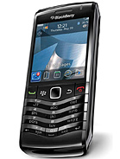 |  |  | 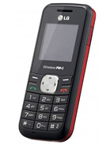
Camera | 0.5 MP |  | Camera | None
Storage | 256 MB |  | Storage | N/A
Music | Yes |  | Music | No
Video | Yes |  | Video | No
E-Mail | Yes |  | E-Mail | No
Connectivity | WiFi, Bluetooth, GPS |  | Connectivity | N/A
Nokia X3 |  |  | Samsung Gravity SMART
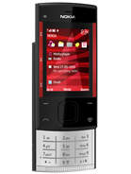 |  |  | 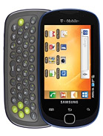
Camera | 3 MP |  | Camera | 3 MP
Storage | 46 MB |  | Storage | 32 GB
Music | Yes |  | Music | Yes
Video | Yes |  | Video | Yes
E-Mail | Yes |  | E-Mail | Yes
Connectivity | Bluetooth |  | Connectivity | WiFi, Bluetooth, GPS

